All Saints Parish
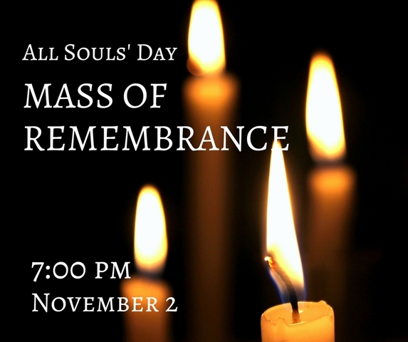
Mass of Remembrance

FOR THE COMMEMORATION OF THE FAITHFUL DEPARTED
TUESDAY, NOVEMBER 2, 2021 AT 7:00PM

Honor the memory of your loved ones who have passed this year
(October 31, 2020 – November 1, 2021)

Please fill in the names of your loved ones (two souls per family) to be included in the Mass and program. All fields must be completed and the date of death must fall within the year (Oct. 31, 2020 – Nov. 1, 2021). Otherwise, we invite you to participate in the All Souls Novena of Masses.

We invite you to bring a framed photo (no larger than 8 x 10), accompanied by a note-card size identification tag, to be displayed during the Mass on the Tables of Remembrance. At the conclusion of the service, please be sure to take your picture home with you.

Please print:

1.Name of Deceased____________________________________________________ DOD_______________

Relationship to Deceased__________________________________________________________________

2.Name of Deceased____________________________________________________DOD________________

Relationship to Deceased__________________________________________________________________

Your Name: __________________________________________Phone:_______________________________

Please return this form to the office or scan and email to l.leach@allsaintsdunwoody.org. You may also include the phonetic pronunciation of any names that might be difficult to pronounce.

All names must be received by October 26, 2021.

